South Asia Regional Workshop on the Global Financial and Economic Crisis and its Impact on Women: A Human Rights Perspective.
August 22-23, 2010
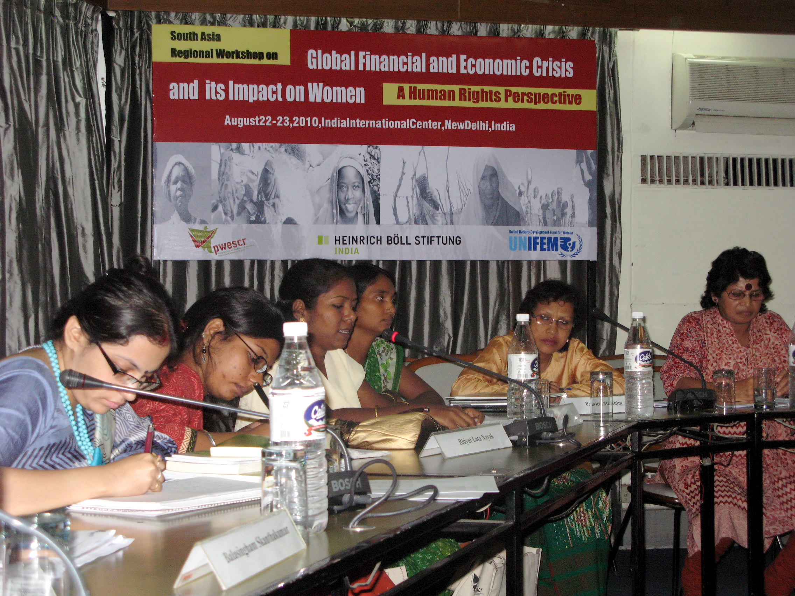
PWESCR, with the support of UNIFEM and Heinrich Böll Stiftung, hosted a South Asia regional workshop at the India International Centre, New Delhi, India, to discuss the impacts of the global financial and economic crisis on women from a human rights perspective. Twenty-two representatives from Afghanistan, Pakistan, Bangladesh, Sri Lanka, Nepal, and from a spectrum of regions across India, attended the event. Participants were drawn from all sectors including local, State and federal Government and the UN, women’s rights NGOs, Tribal women’s groups, labour unions, political economy, law, media and academia.

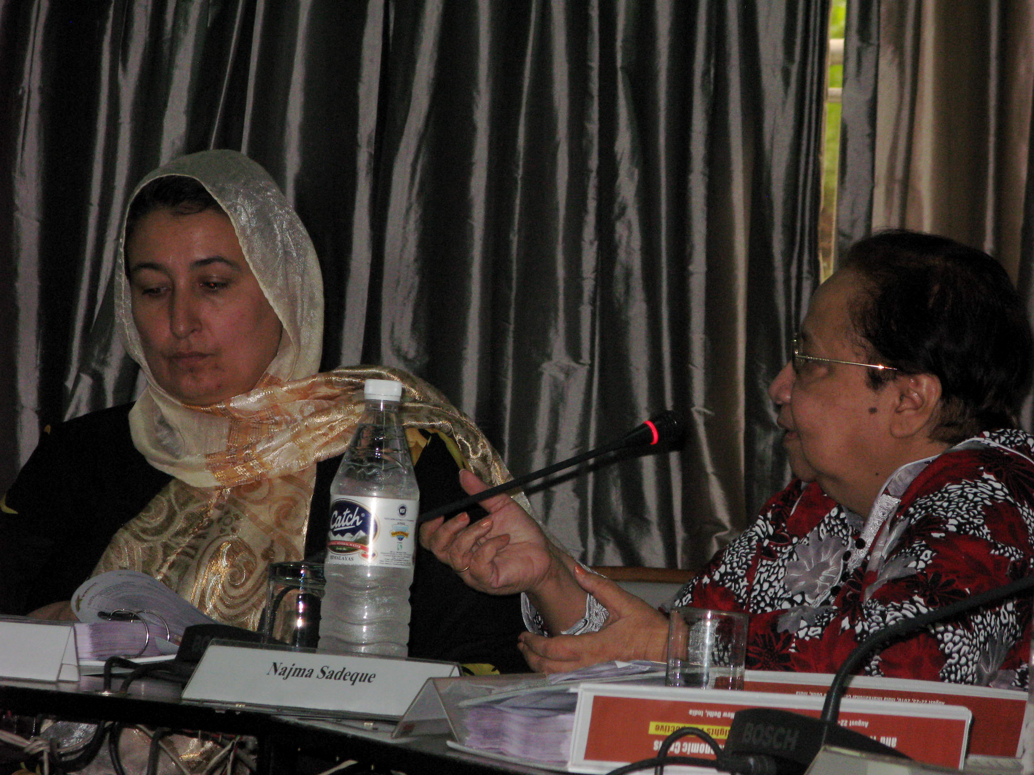
The current global crisis began in the housing sector of the US economy, spilled over into the financial sector moving on to the real sector of the developed and developing world, causing immense hardship for millions of poor and vulnerable people in developing countries in the process. Women, in particular, are adversely affected by the current crisis, which itself combines multiple crises: a global economic recession, the devastating effects of climate change, and an ongoing food and energy crisis. All of this is compounding increasing poverty and inequality in different parts of the world, as well as the increased vulnerability of women in particular where adverse health and nutritional impacts are concerned. The crisis is not new for most of the developing countries that have struggled with crises right from the 70’s with women’s group in particular emphatically voicing their protest and resistance to such policies in terms of its destructive effects on women’s livelihoods, increased burdens of work and unpaid labour as well as loss of social security nets. This crisis, however, reached global proportions when it impacted advanced economies and their role in global arenas thereby bringing out the interconnectedness of the divergent realities in a globalised world.

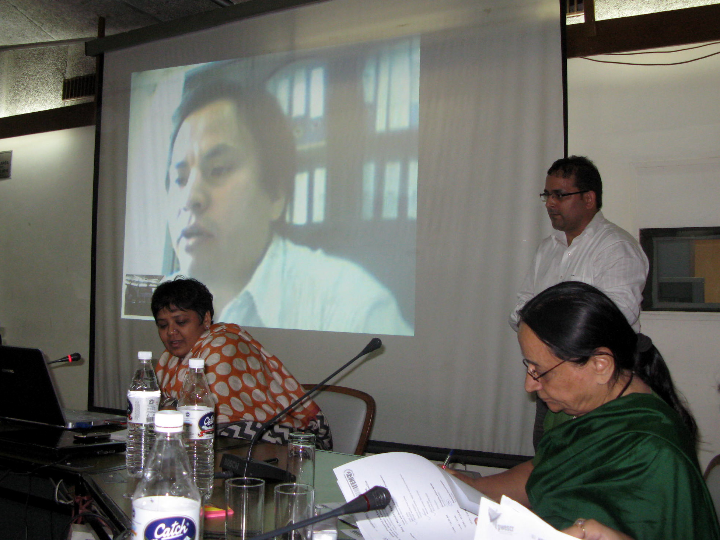
Accordingly national as well as international institutions are facing diverse pressures in the fields of growth, employment, food security and fiscal policy formulations in terms of framing adequate responses to contain both the financial sector crisis and the meltdown of production and employment all around the globe. The crisis also provides an opportunity to rethink macro and micro economic policies, and for those advocating a gender based approach in designing policy frameworks to advance proposals that promote jobs, economic security and human rights, and equality by class, gender, and ethnicity. Reviving the global economy will require policies that focus heavily on job creation and ensure a more equitable and sustainable development process that protect and enhance women’s livelihoods. The inclusion of women and gender equality within a framework of human rights is central to these processes and an indicator of both the seriousness as well as efficacy of proposed responses. In this context, there are few studies focusing on the gendered impacts of the global financial and economic crisis on the South Asian countries. Common economic analyses highlight the social impact using financial indicators. However, this approach ignores women and other sections of society who function outside the neo-liberal economic framework. There is seemingly a gap in policymakers’ understanding of the issue and, more importantly, in women’s ability to ensure protection and enforcement of their rights. Further, there is a growing concern that without an integrated gender and human rights approach, the alternatives proposed to address the crisis will continue to increase women’s marginalization and vulnerabilities rather than addressing it.

Ms. Virgina Bras Gomes, UN Economic, Social and Cultural Rights Committee Member since 2003 and current Vice-Chair, and Mr. Manuel F. Montes, Chief of Development Strategy and Policy Analysis in the United Nations Department of Economic and Social Affairs (UNDESA), both PWESCR International Board Members, participated in the workshop. In setting the context for event, Ms. Gomes offered a human rights perspective on women and the crisis, while Mr. Montes presented a global overview.

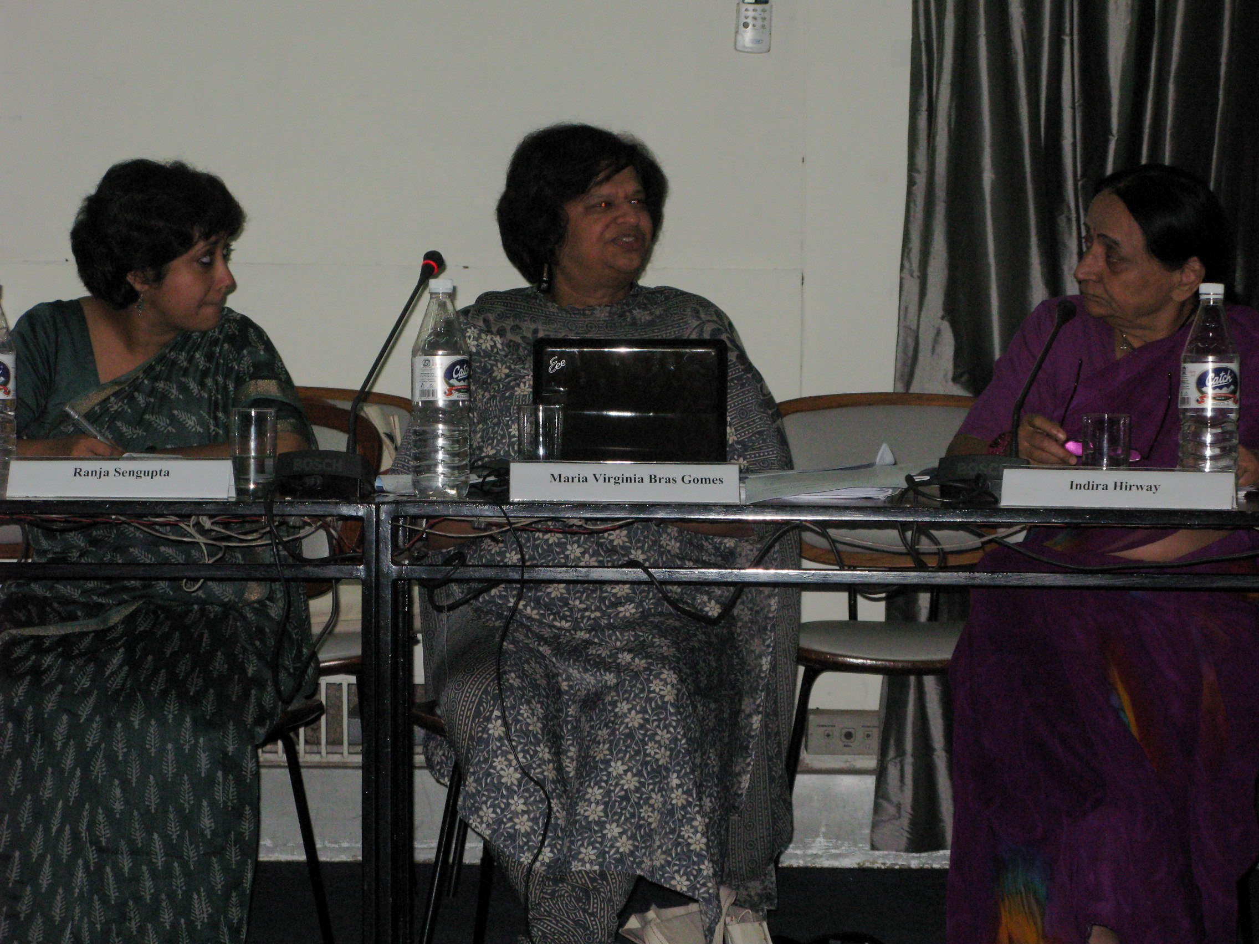
Key topics from day one of the workshop were the Crisis and Women’s Food Security and Migration, the Crisis and Women’s Economic Rights, and the Crisis and Conflict and Issues of International Aid. Day two addressed the Crisis and Women’s Natural Resource Management as well as focusing on policy issues and developing an agenda for the future. A broad range of economic sectors were represented and discussed at the event, including garment making, coir, cashew, fisheries and handloom industries, agriculture and arts and crafts. It was noted that the crisis provides an opportunity to develop alternatives and emphasized women should to be looked at as rights holders at all times rather than as a special category for a larger rights-based approach. Greater participation of women in economic activity through employment and livelihoods as well as land rights and land reform policies, right to productive resources, right to decent work, labour rights and social security was also mentioned. A gender-based stimulus package and gender analyses of the national budget was also proposed. PWESCR is developing a report from this workshop to share the nuances and outcome of the conversations.

